**Technical file**

**Names :**Gal Bachar  
Shahar Baba  
Eden Meshulam  
Daniel George

Contents

0.0.0 Flow Chart - Screens 3

1.0.0 Usage scenarios 4

**1.1.0** **Login / Register screen –** 4

**1.2.0** **Main screen –** 5

**1.2.1.** **When login as Companies / Employers-** 5

**1.2.2.** **When login as Worker-** 6

**1.3.0** **Chat & Notification screens–** 7

**1.3.1** **Chat** 7

**1.3.2** **Notification** 7

**1.4.0.** **Menu –** 8

**1.4.1.** **When login as Companies/Employer** 8

**1.4.2.** **When login as workers** 10

2.0.0 Database 11

3.0.0 Methodologies 12

3.1.0 Front 12

3.2.0 Backend 12

3.3.0 Docker 12

3.4.0 Version Control 12

4.0.0 Platforms 13

4.1.0 IDE 13

4.2.0 Languages 13

1. **Flow Chart - Screens**

If the users reject the offer

If the users already register

Start application

Register Flow

Login page

If the users don’t register

Main Page - Workers

Main Page – Companies / Employers

If the users accept the offer

Chat page

If the users reject the offer

1. **Usage scenarios**
   1. **Login / Register screen –**

**(Workers and Companies / Employer)**

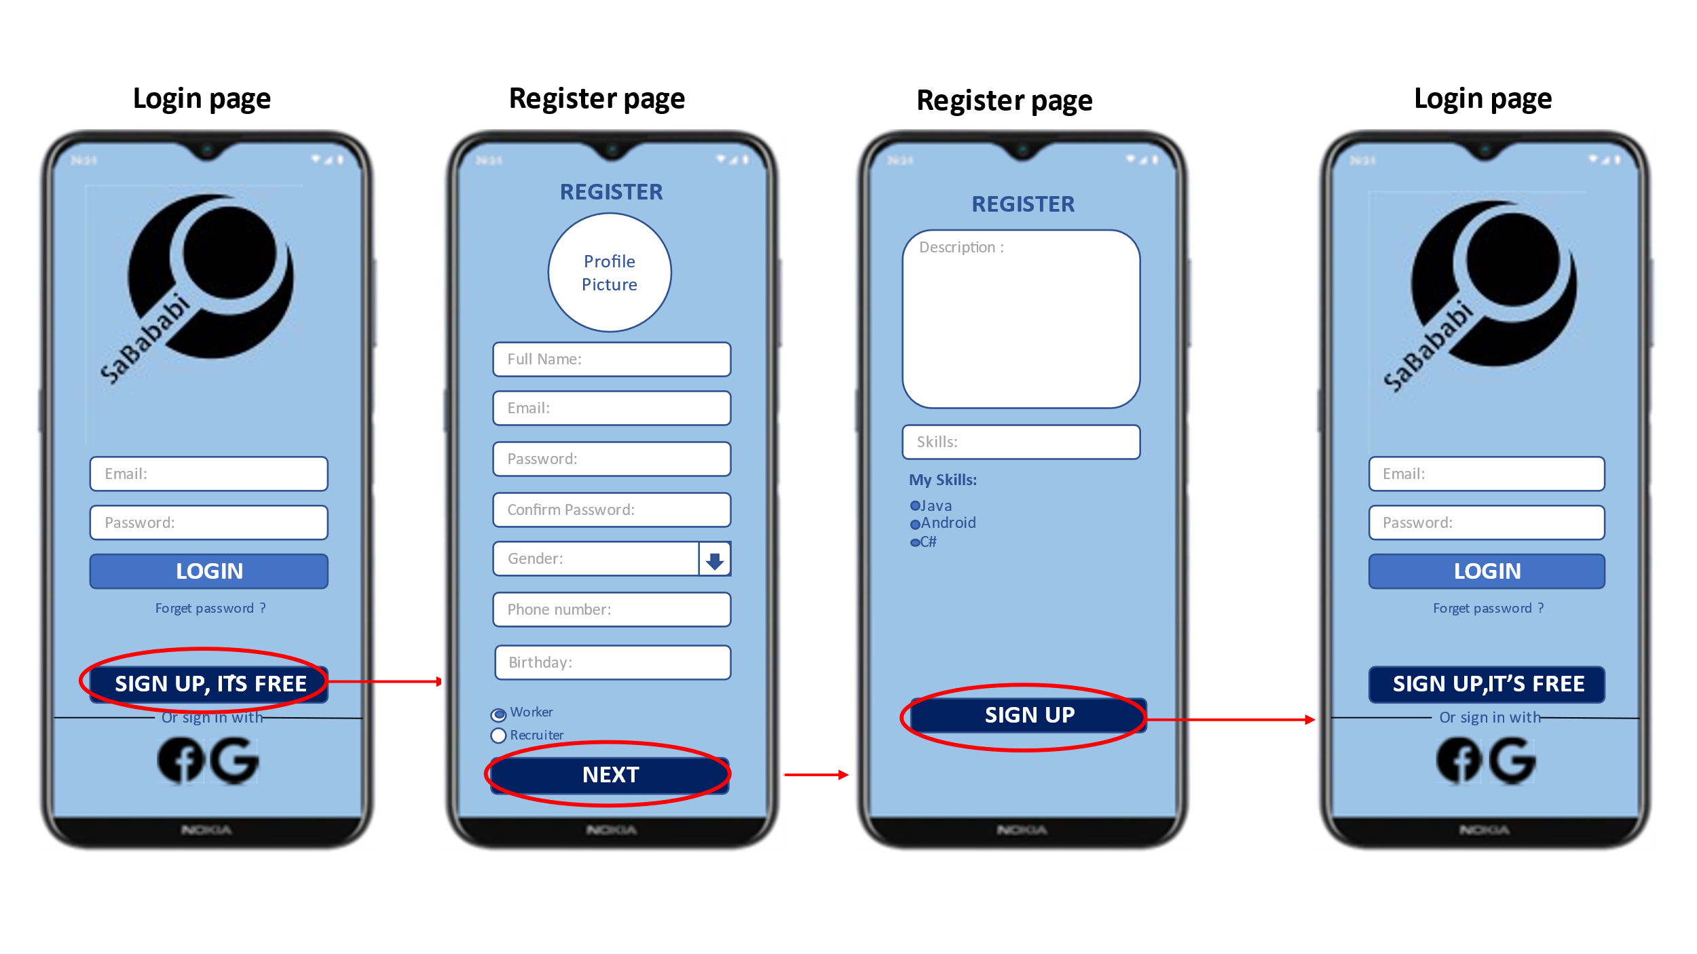A screen where you log-in / register to the application.

* 1. **Main screen –**

(shows one ad at a time respectively).  
One ad is displayed at a time which can be expanded -  
Possible actions:  
Accept, Reject, Cancel.

* + 1. 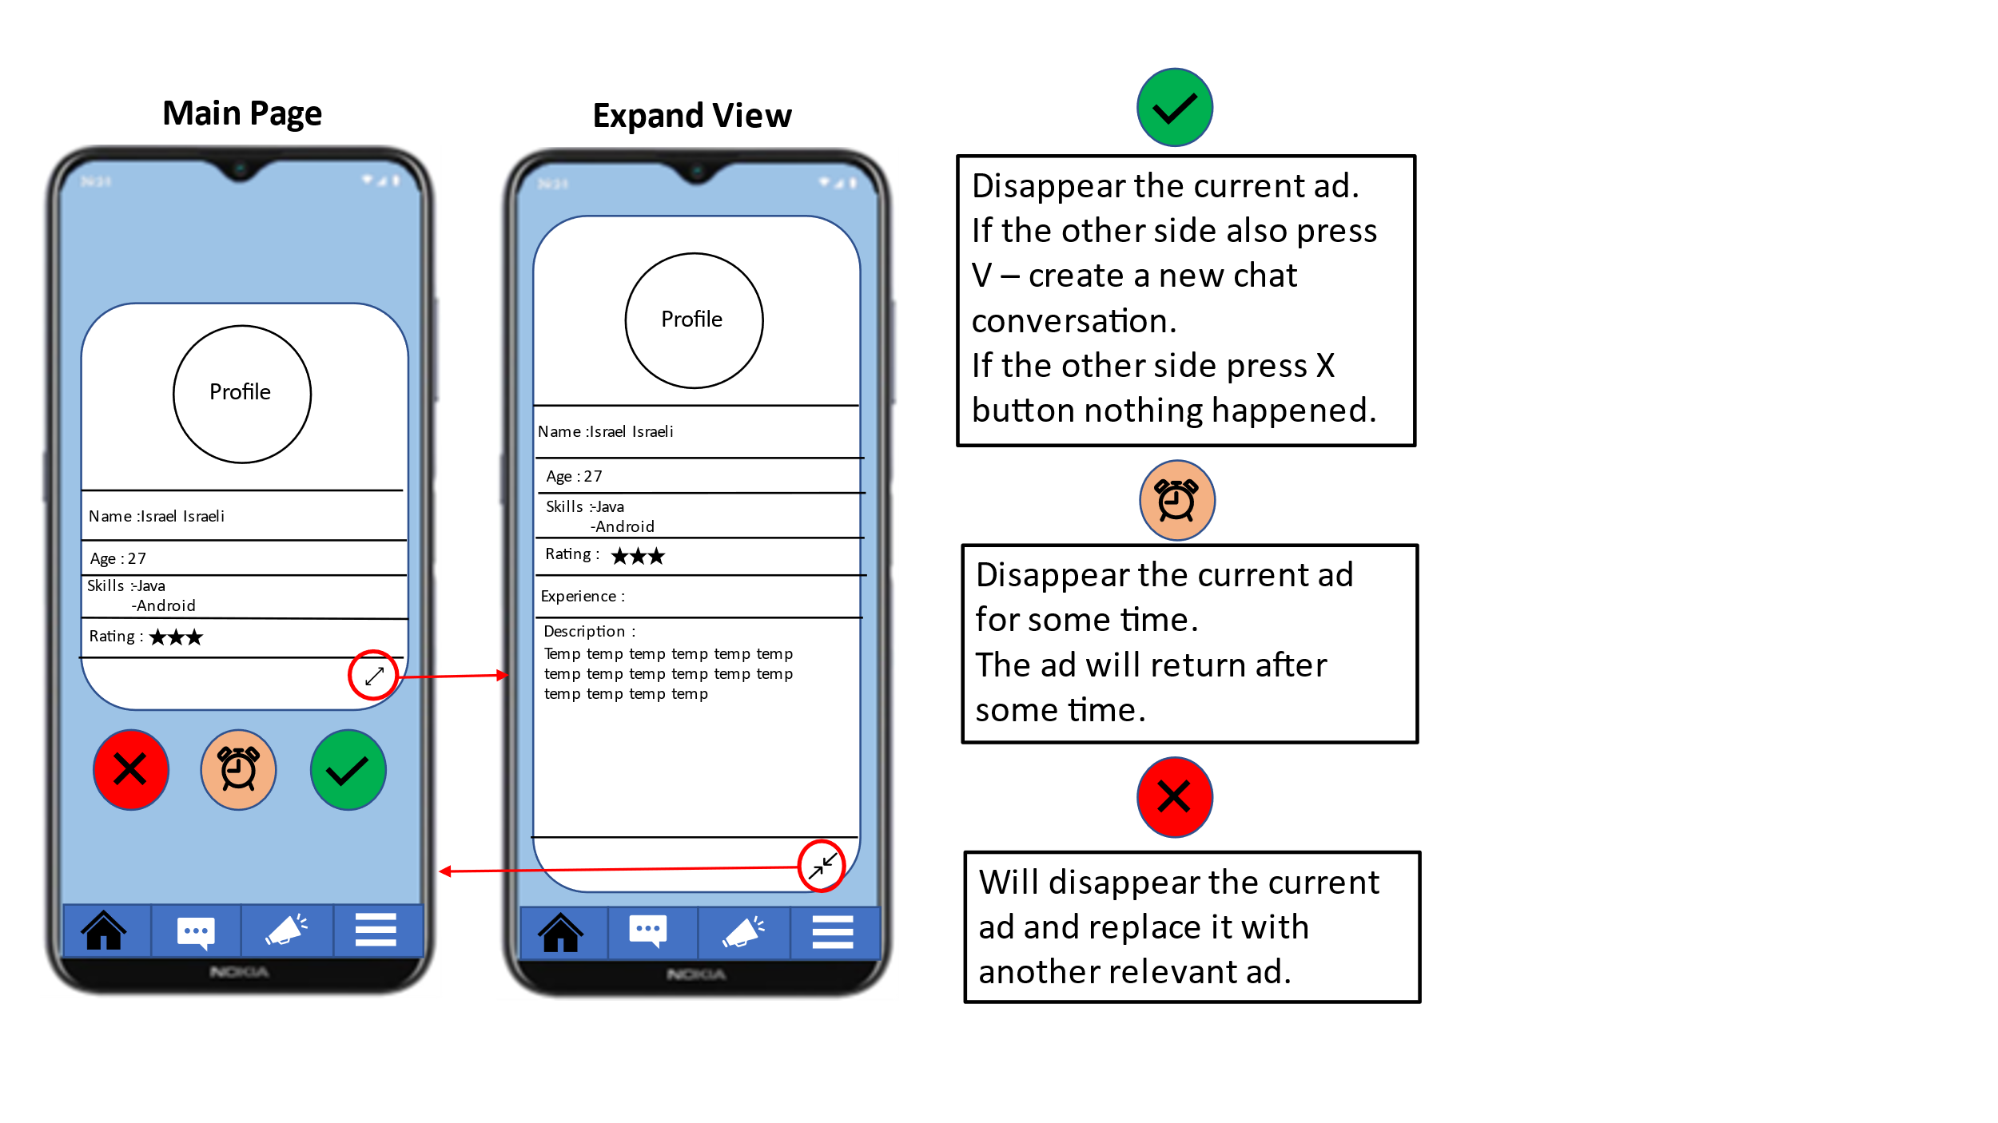**When login as Companies / Employers-**

Each ad contains:  
Photo, personal information, rating and more relevant information.

* + 1. **When login as Worker-**

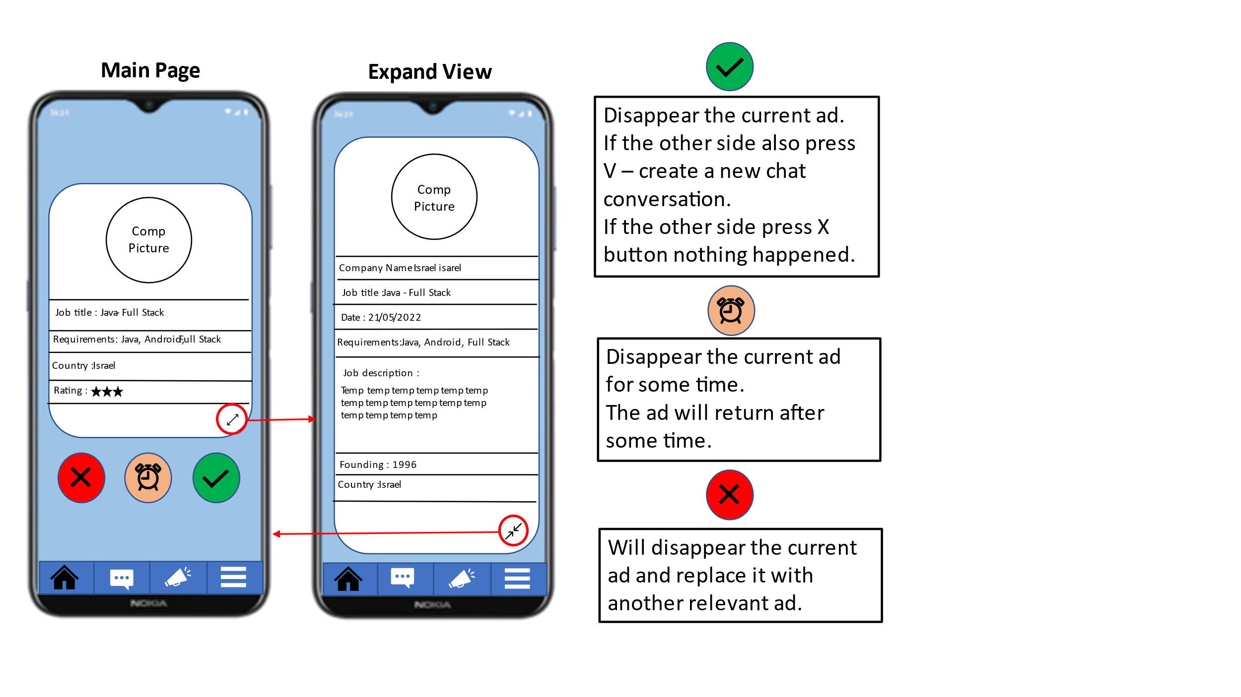Each ad contains:  
Company logo, company information, rating and more relevant information.

* 1. **Chat & Notification screens–**

**(Workers and Companies / Employer)**

* + 1. **Chat**

The chat contains two screens:  
First screen - screen of all conversations.  
Second screen – screen of current conversation.  
(conversation Will only be displayed after agreement by 2 sides).

* + 1. 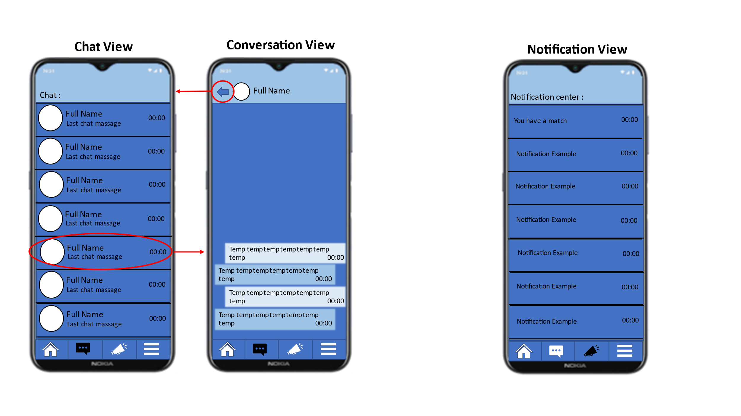**Notification**

Displays relevant notifications  
Contains only one screen that displays the list.   
Clicking on each ad jumps to a relevant exzisting screen.

* 1. **Menu –**
     1. 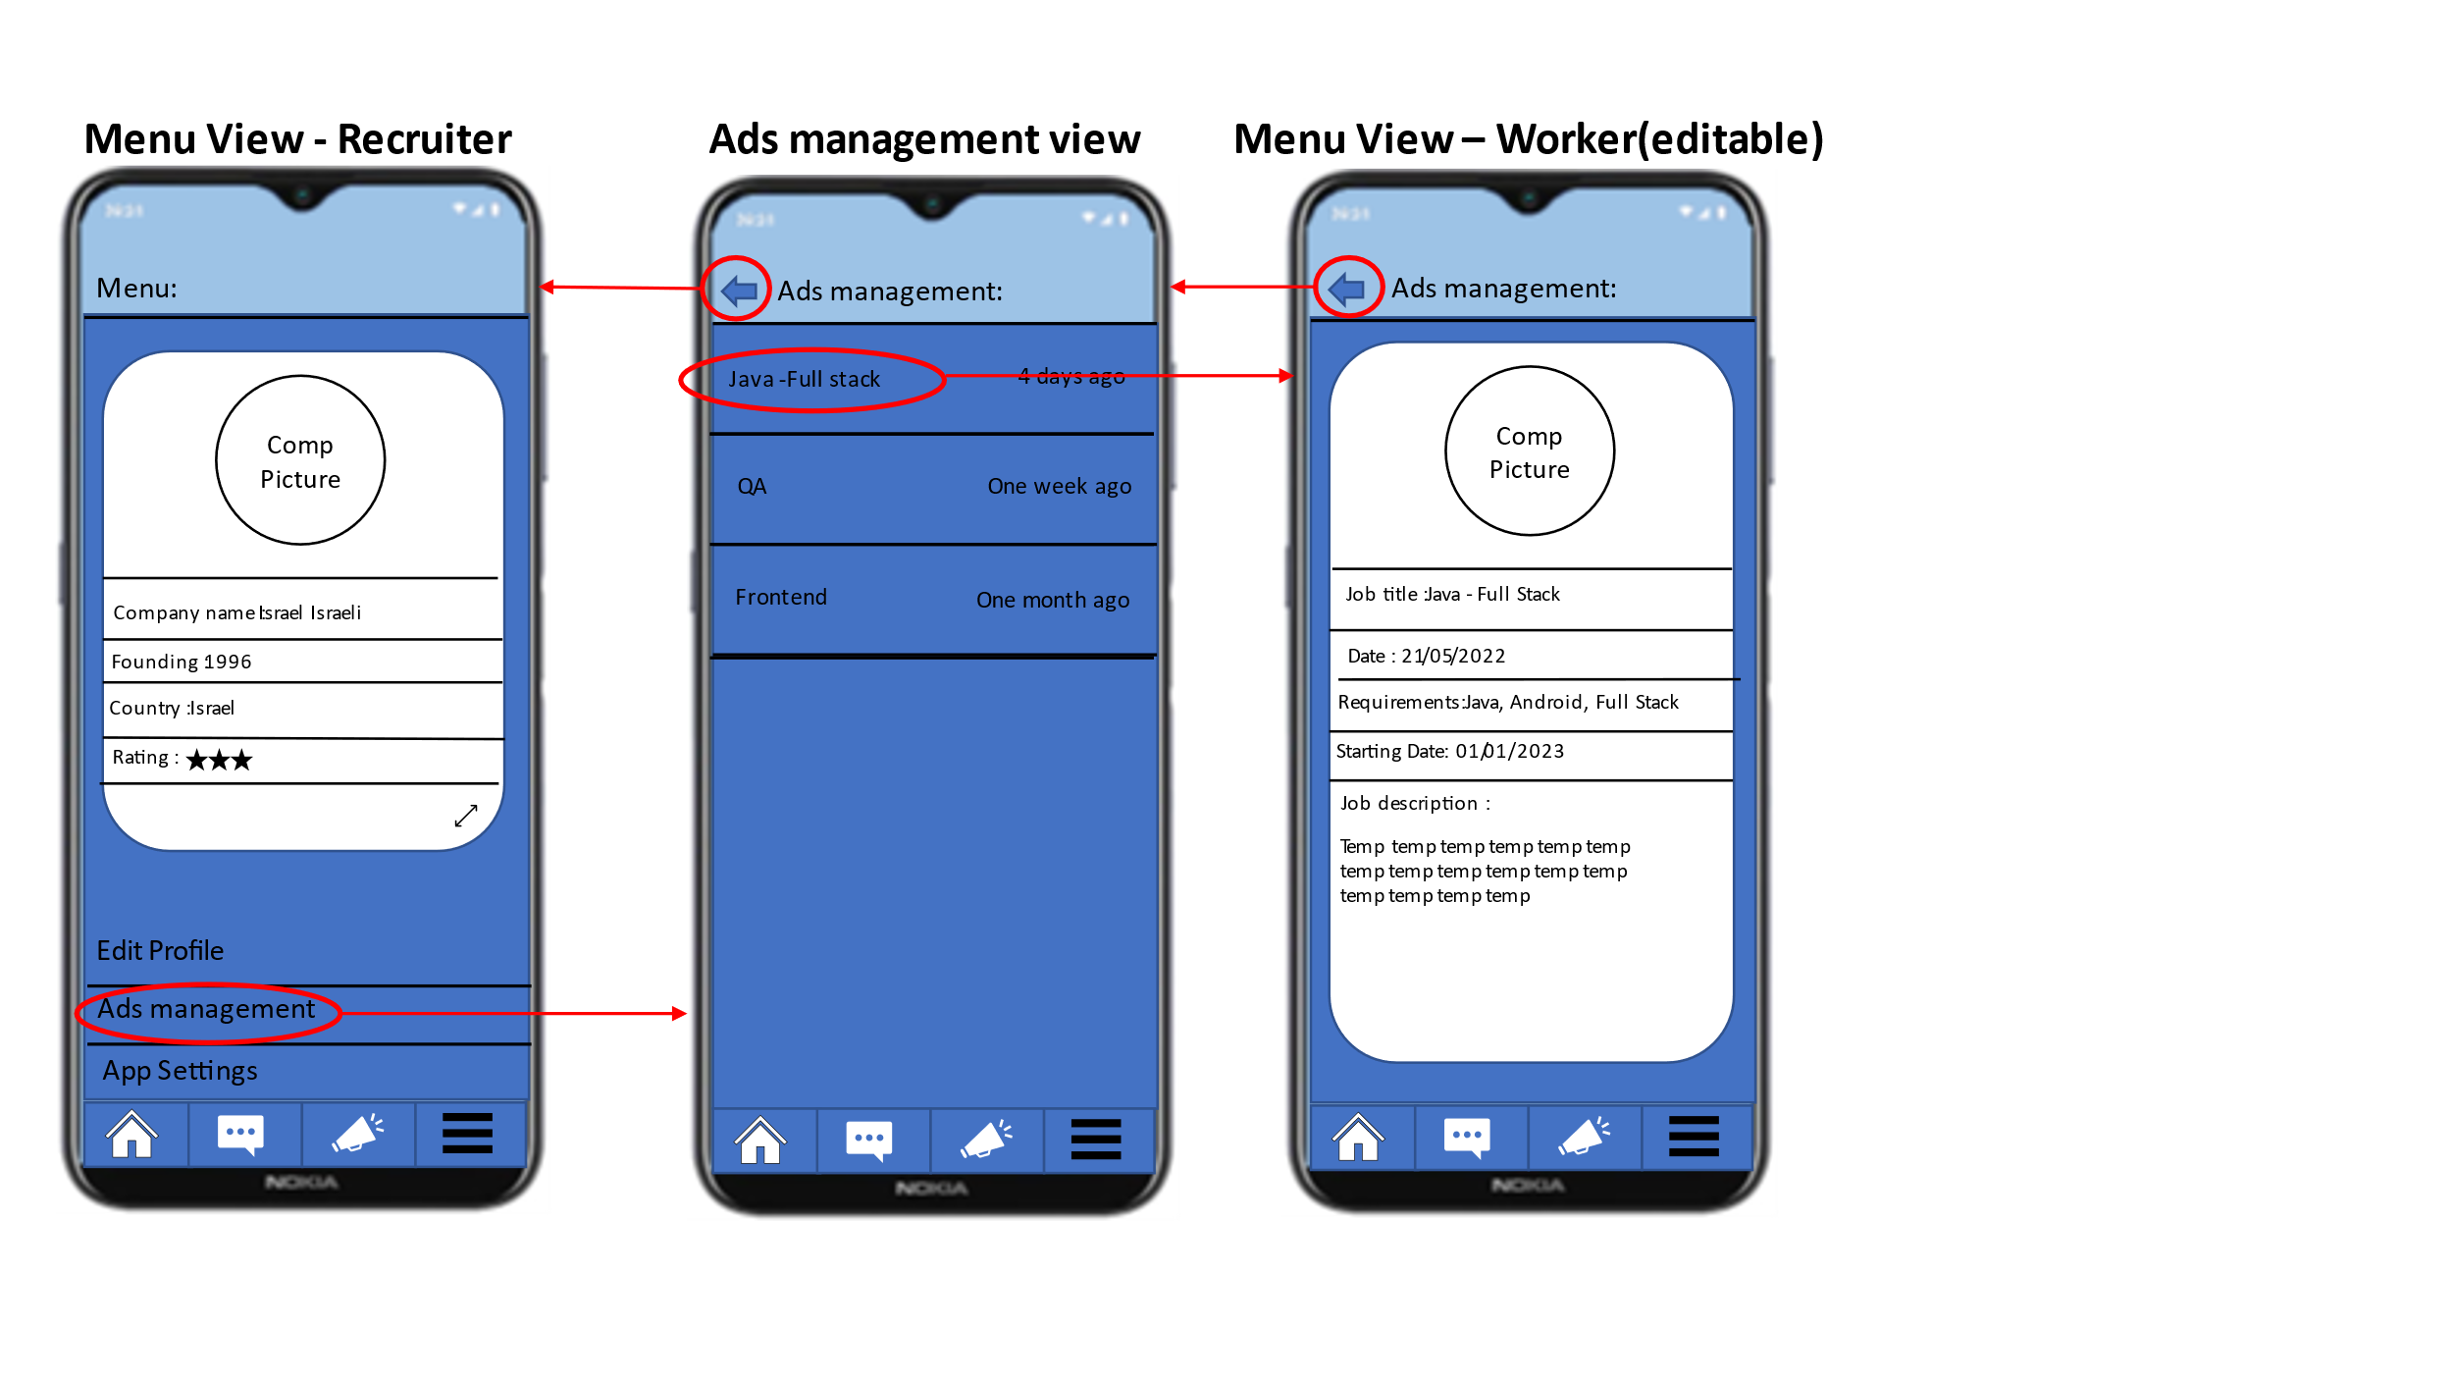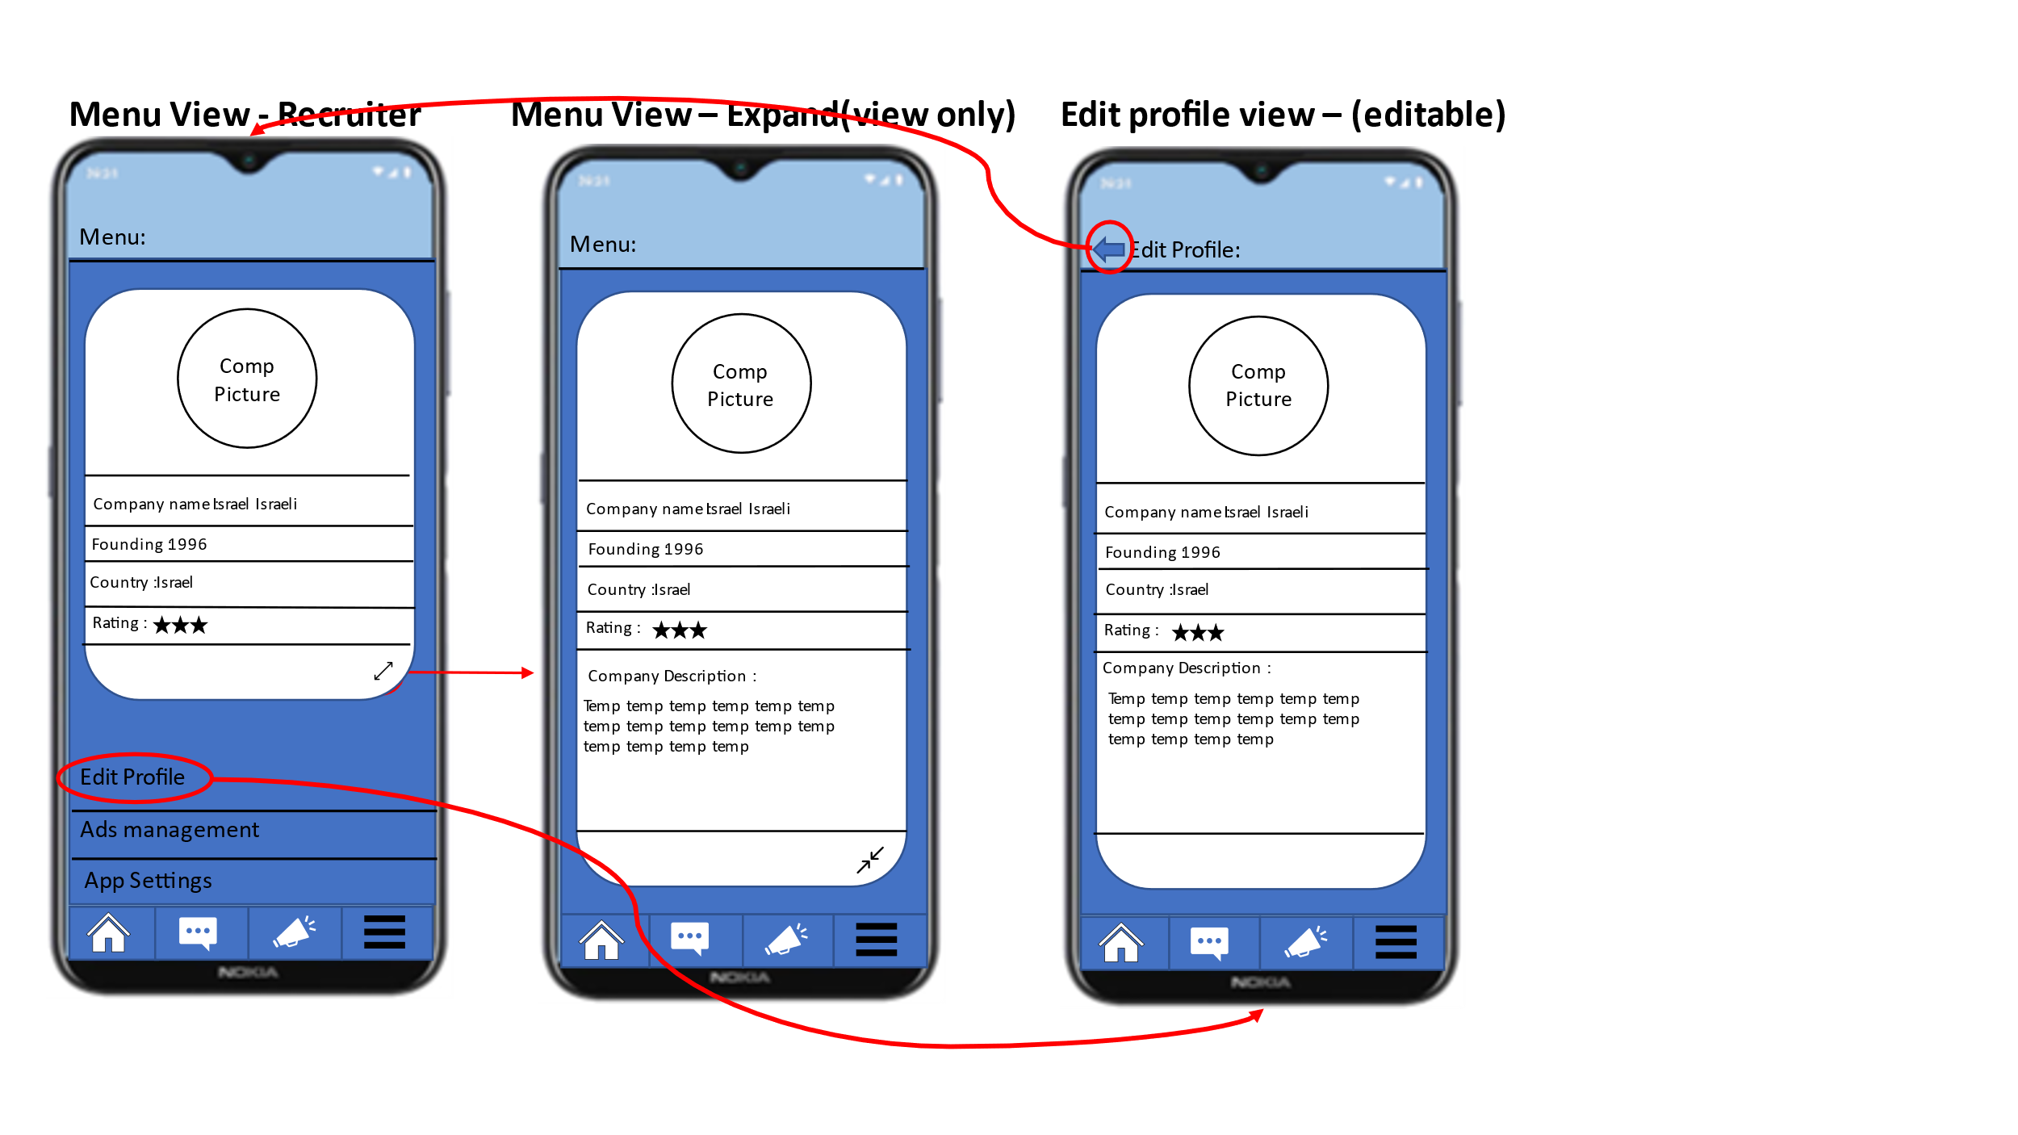**When login as Companies/Employer**

Contains three screens:  
* Profile screen - Where you can edit and view the job seeker's profile  
* Ad management screen - A screen where the company's ads are displayed and can be managed (edit / delete).  
* Application settings screen - A screen where you can edit the settings of the application.  
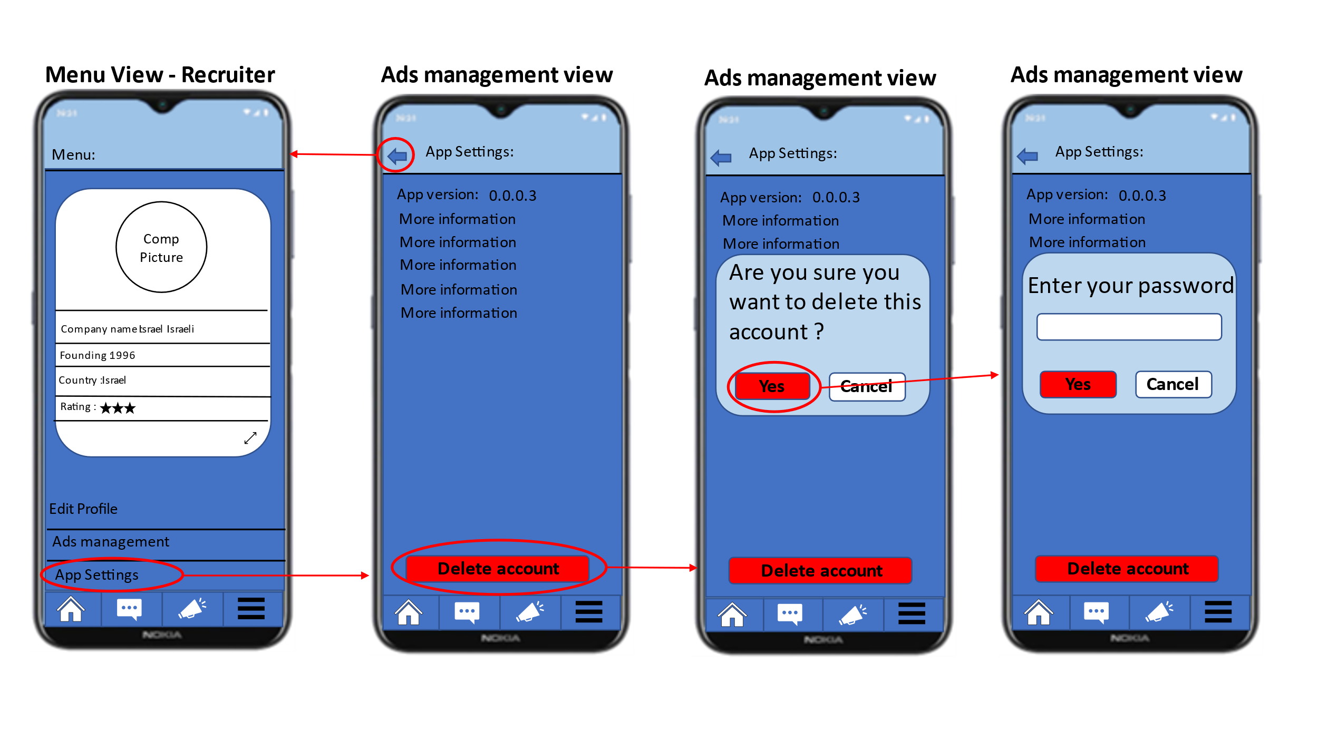

* + 1. 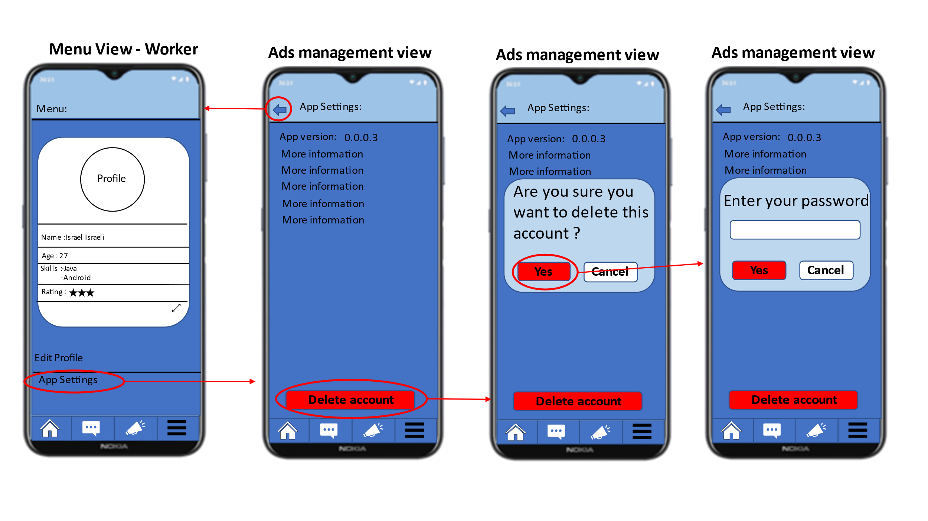**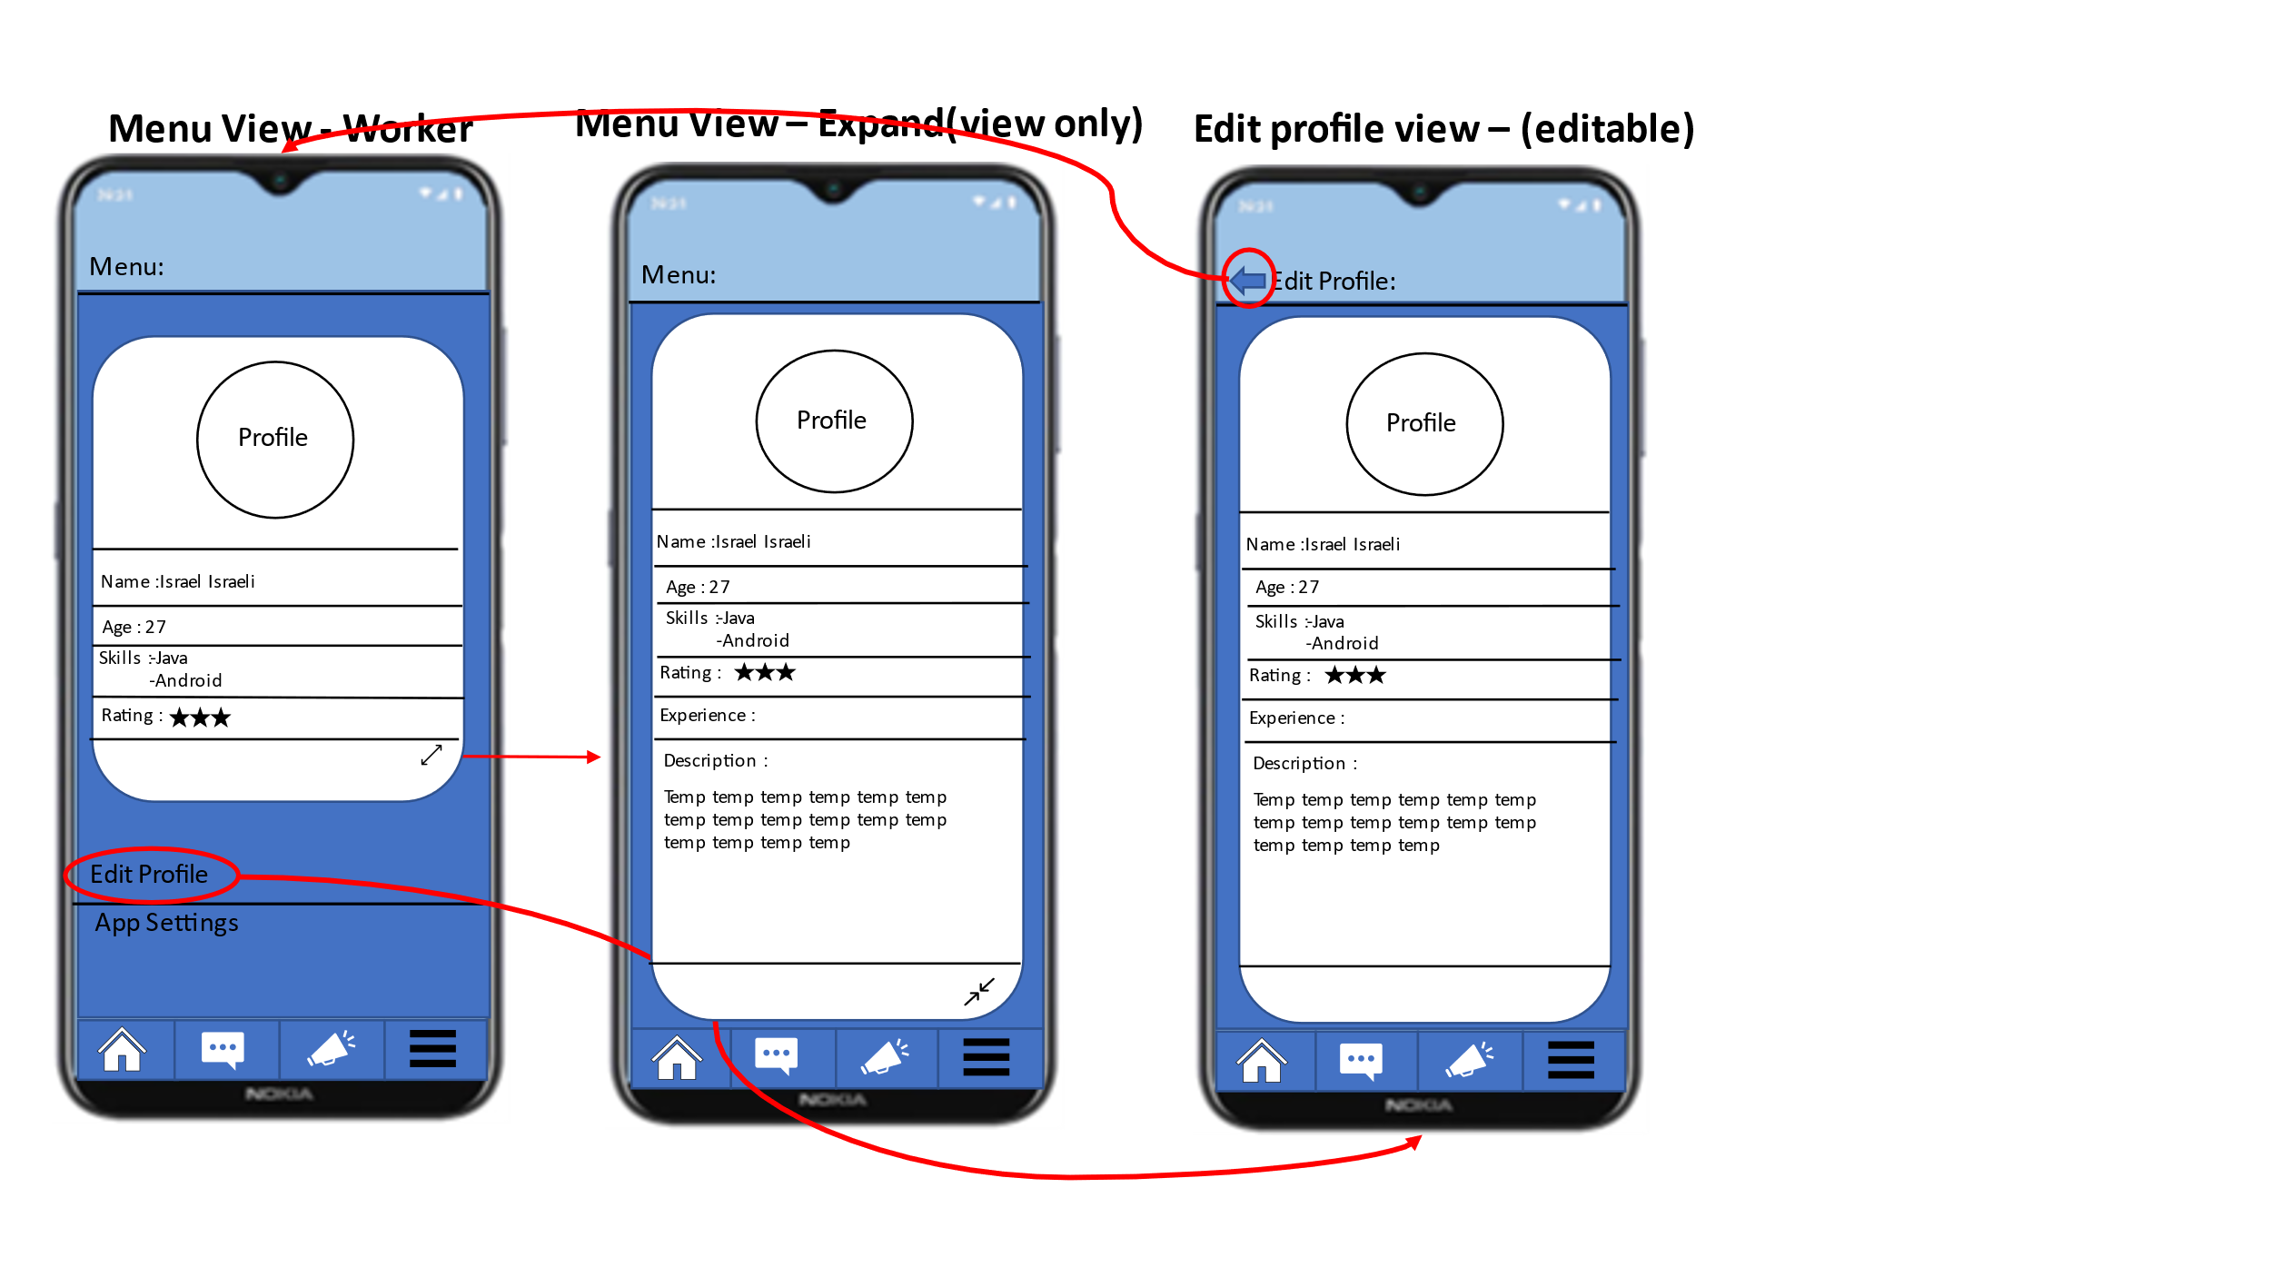When login as workers**

Contains two screens:  
* Profile screen - Where you can edit and view the job seeker's profile  
* Application settings screen - A screen where you can edit the settings of the application.

1. 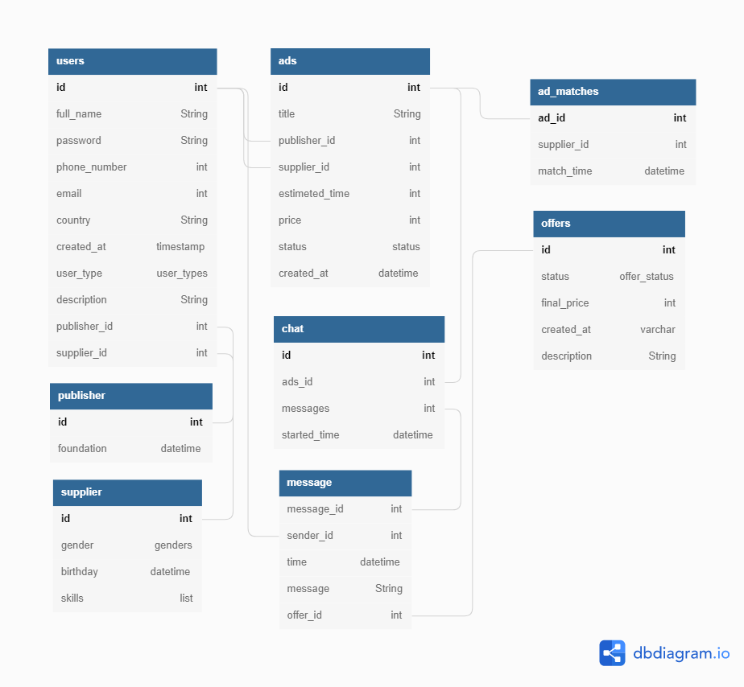[**Database**](https://dbdiagram.io/d/628e75b2f040f104c198da98)
2. **Methodologies**

**3.1.0** **Front**  
In the front part of our project we used React Native.  
React Native is and open-source software framework that used to develop applications for Android iOS and web.  
This is the main reason for us to use react native we wanted a cross platform application that will be available to all kind of users.  
Another reason for us to use react native is that we wanted to learn new technologies

**3.2.0** **Backend**  
In the backend part of our project we used Python.  
Python is a [high-level](https://en.wikipedia.org/wiki/High-level_programming_language), [general-purpose programming language](https://en.wikipedia.org/wiki/General-purpose_programming_language) python is a reach full language and includes a lot of modules and libraries so in the future we could implement with python new features from the world of machine learning and AI in our project.  
Another reason to use Python in our project is that we wanted to learn new technologies and in the front part we use React Native so we wanted to learn more tools that will help us in the industry in the future.  
The server part we developed over Flask library that we use for Rest API and HTTP calls.

**3.3.0 Docker**  
In the Development process we used Docker by creating image.  
With this technology our work was organized.  
We didn’t need to do any local installs on our computers and the work environment was the same as the production environment .

**3.4.0 Version Control**  
 GitHub

**4.0.0** **Platforms**

**4.1.0 IDE**  
Our system developed in Visual Studio Code.  
Visual Studio Code is a [source-code edito](https://en.wikipedia.org/wiki/Source-code_editor)r.  
Features include support for [debugging](https://en.wikipedia.org/wiki/Debugging), [syntax highlighting](https://en.wikipedia.org/wiki/Syntax_highlighting), [intelligent code completion](https://en.wikipedia.org/wiki/Intelligent_code_completion), [snippets](https://en.wikipedia.org/wiki/Snippet_(programming)), [code refactoring](https://en.wikipedia.org/wiki/Code_refactoring), and embedded [Git](https://en.wikipedia.org/wiki/Git).

**4.2.0 Languages**  
 JavaScript , Python.